**PDF Report for Programming Assignment**

**Analysis of Grid Graphs:**

1. Yes, both of the probability distribution graphs for G1gr and G4gr follow the same pattern. As a matter of fact, they look almost identical (which is accentuated with the same colors being used for the same probabilities). However, the graph for G4gr has a slightly higher probability distribution. This tells us a pretty intuitive fact that as there are more sources for a disease, the probability for infection is higher (assuming the network is the same).
2. The average day of infection for p=.1, p=.3, p=.5 and p=.7 for G1gr and G4gr respectively are:

Days 2 & 3, Days 6 & 9, Days 30 & 32, and Days 21 & 23. Hence, although the average day of infection for greater infection rates is higher, the resulting amount of infected nodes that day is far greater.

1. The same patterns as in (1) are observed. That is, G1gs and G4gs follow the same pattern, but G4gs has a higher distribution. In addition, both G1gs and G4gs have a higher distribution than their G1gr and G4gr counterparts. Just look at when p=.5. It’s almost the same as when p=.7. Hence, more connections also contribute to higher rates of infection.
2. The average day of infection for p=.1, p=.3, p=.5 and p=.7 for G1gs and G4gs respectively are:

Days 2 & 4, Days 20 & 18, Days 20 & 9, and Days 8 & 7 which is a different pattern than in (2) to say the least. It appears that since these networks are so well connected, then it takes way less time for multiple source nodes to infect a lot more nodes than a network with one source node.

1. As stated before, the probability distribution of infection for both G1gs and G4gs is higher than that of G1gr and G4gr. In addition, the average day of infection is much lower when there’s more connections (a.k.a. in G1gs and G4gs).
2. There’s not much room for opinion here. You can clearly see that with more connections the probability distribution of infection increases drastically. (Look at p=.3 in G1gs and G4gs compared to in G1gr and G4gr for the most apparent example)
3. I’ve actually seen a bit of percolation theory in my physics class, but to avoid over-explanation through Calculus that I can barely understand I’ll say that it basically comes down to the geometry of the lattice/network and the amount of dimensions, in this case 2, that we’re working with and how (on average) you can fail to infect at most two nodes (not three since the third connection is an active edge) and still manage to pass on the disease.

**Analysis of scale free graphs:**

1. Much like before, the infection distributions of GHsf and GLsf are much higher than that of G1gs and G4gs. In addition, the distribution for p=.5 & p=.7 of GHsf are nearly identical, and in general it seems that the distributions for all probabilities of GHsf are higher than those of GLsf.
2. The average day of infection for p=.1, p=.3, p=.5 and p=.7 for GHsf and GLsf respectively are:

Days 7 & 9, Days 4 & 6, Days 3 & 4, and Days 3 & 3. Just like before, as p increases, the average day of infection lowers. However, now we can see that the shortest time for average infection appears to be 3 days since no graph went past that.

1. It appears as though those nodes with a high degree are a lot more likely to get infected (from node 0 to 10-ish). However, I don’t quite see a correlation between distance from source node and rate of infection. It’s probably there, but it pails in comparison to how much more likely a node with many connections is to get infected.

**Plots:**

(Probability Distribution for G1gr X:Nodes Y:Probability of Infection):

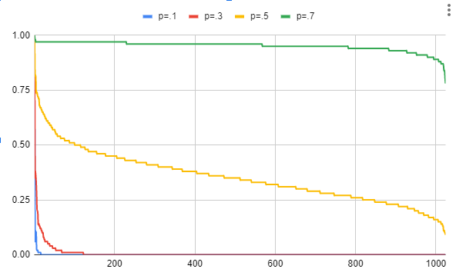

(Probability Distribution for G4gr X:Nodes Y:Probability of Infection):

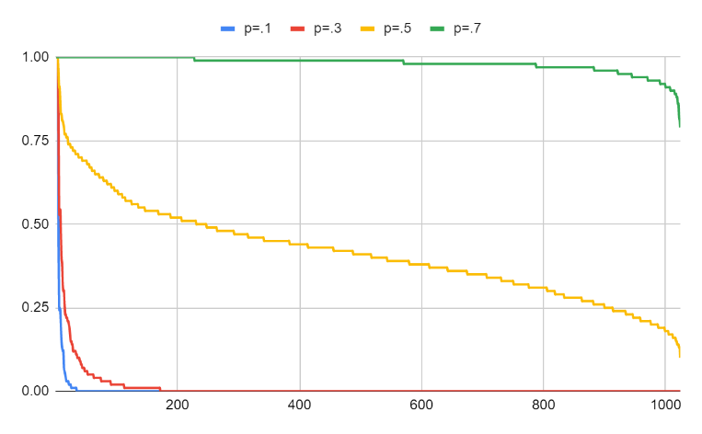

Average day of infection (with p=.1 & p=.3) for G1gr X:Day Infected Y:Number of nodes Infected

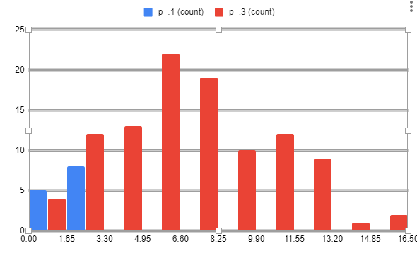

Average day of infection (with p=.5 & p=.7) for G1gr X:Day Infected Y:Number of nodes Infected

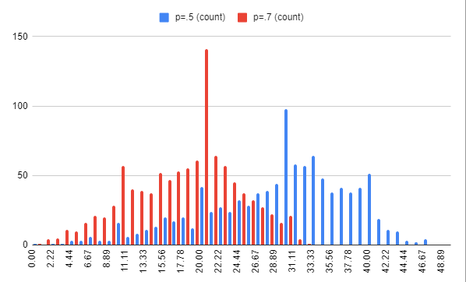

Average day of infection (with p=.1 & p=.3) for G4gr X:Day Infected Y:Number of nodes Infected

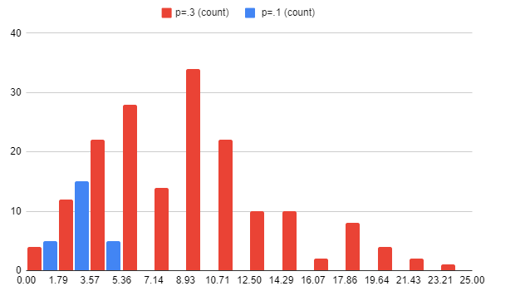

Average day of infection (with p=.5 & p=.7) for G4gr X:Day Infected Y:Number of nodes Infected

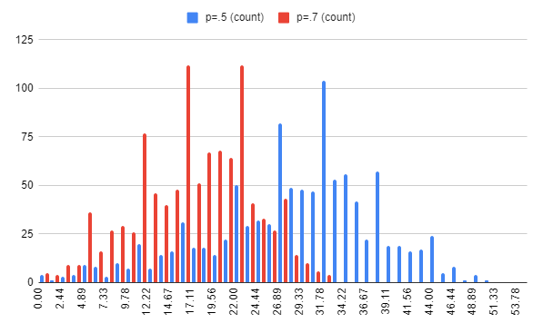

(Probability Distribution for G1gs X:Nodes Y:Probability of Infection):

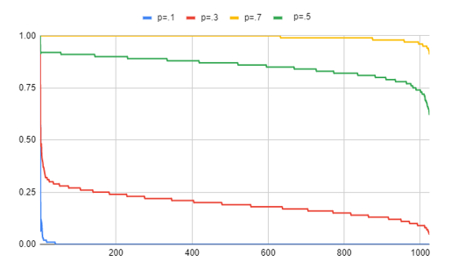

(Probability Distribution for G4gs X:Nodes Y:Probability of Infection):

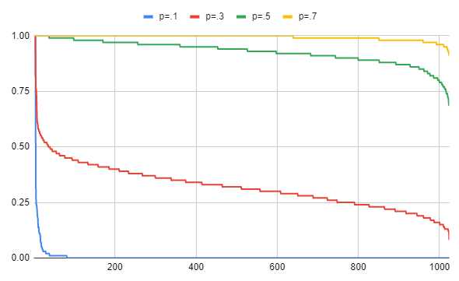

Average day of infection (with p=.1 & p=.3) for G1gs X:Day Infected Y:Number of nodes Infected

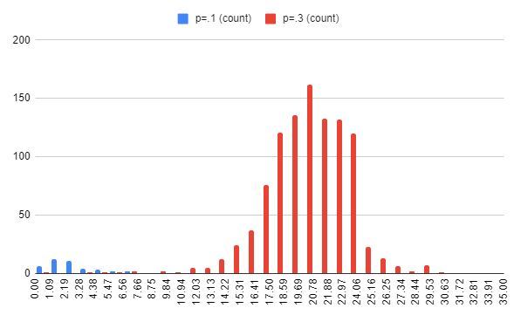

Average day of infection (with p=.5 & p=.7) for G1gs X:Day Infected Y:Number of nodes Infected

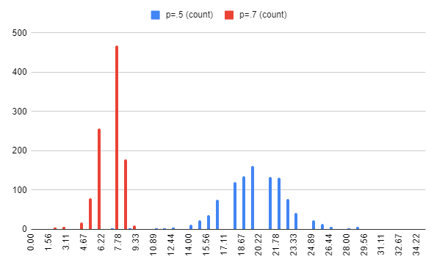

Average day of infection (with p=.1 & p=.3) for G4gs X:Day Infected Y:Number of nodes Infected

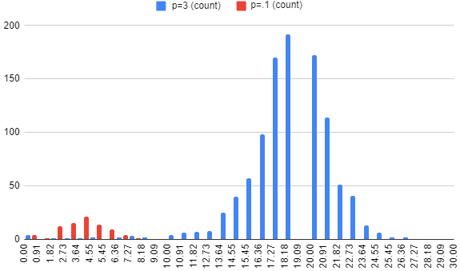

Average day of infection (with p=.5 & p=.7) for G4gs X:Day Infected Y:Number of nodes Infected

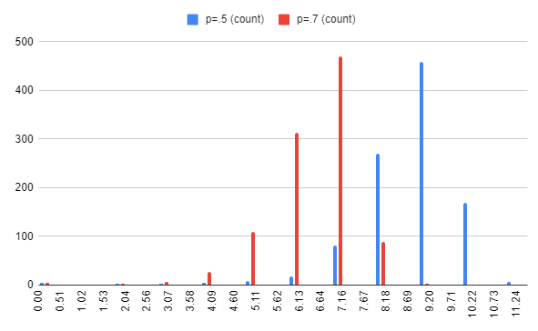

(Probability Distribution for GsfH X:Nodes Y:Probability of Infection):

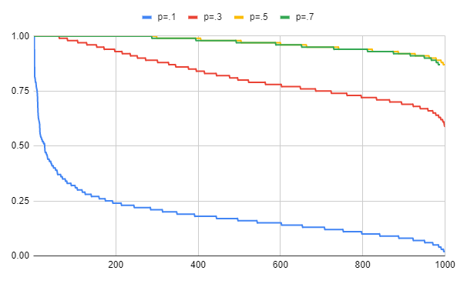

(Probability Distribution for GsfL X:Nodes Y:Probability of Infection):

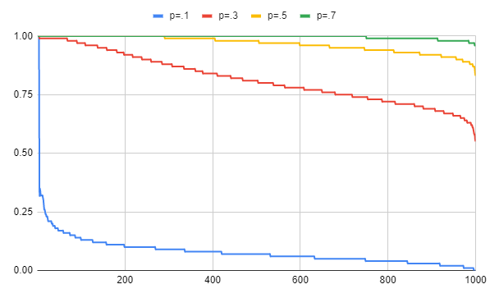

Average day of infection (with p=.1 & p=.3) for GsfH X:Day Infected Y:Number of nodes Infected

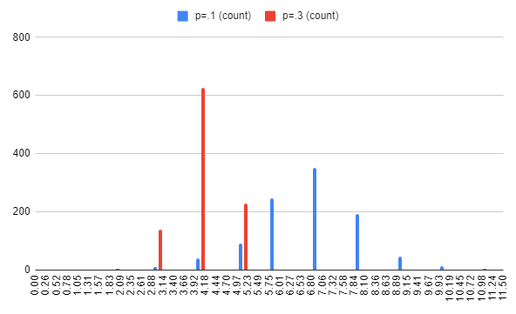

Average day of infection (with p=.5 & p=.7) for G1gs X:Day Infected Y:Number of nodes Infected

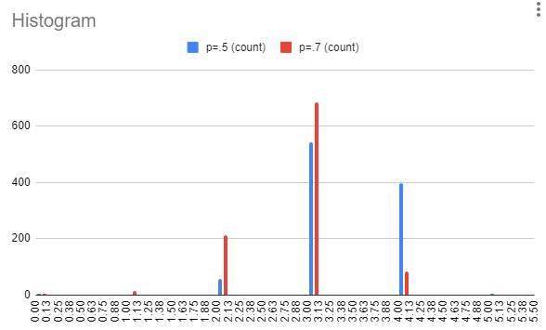

Average day of infection (with p=.1 & p=.3) for GsfL X:Day Infected Y:Number of nodes Infected

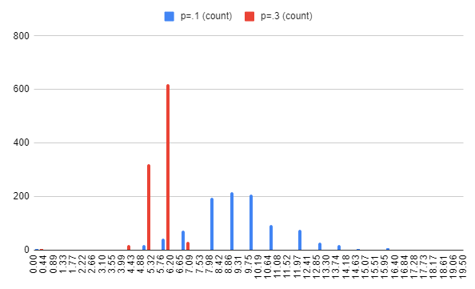

Average day of infection (with p=.5 & p=.7) for G1gs X:Day Infected Y:Number of nodes Infected

